



School: ............................................................................................................. Campus: ....................................................... Academic Year: ...................... Subject Name: ........................................................... Subject Code: ..........................

Semester: ............... Program: ........................................ Branch: ......................... Specialization: .......................... Date: .....................................

(Learning by Doing and Discovery)

**\* Coding Phase: Pseudo Code / Flow Chart / Algorithm**

ALGORITHM:

1. Start.
2. Open Chrome Browser on your system.
3. Search for a Core Wallet Extension (or the desired crypto wallet extension).
4. Click on the "Add to Chrome" button.
5. Once added, open the extension from the toolbar.
6. Click on "Create Wallet Manually."
7. Note down the Seed Phrase carefully:

* It will be shown only once.
* Do not share it with anyone.
* If lost, it cannot be recovered.

1. Verify the seed phrase as per the prompt.
2. Set a Wallet Name and create a secure password.
3. Confirm wallet creation.
4. After successful setup, the wallet dashboard or portfolio page will be displayed.
5. End.

# * Software used

1. **Chrome/Brave Browser** – Used to install and access the wallet extension.
2. **Core Wallet Extension** – For creating and managing the cryptocurrency wallet.

Since this experiment involved setting up a wallet extension rather than coding, the testing phase focused on verifying each step of the setup process:

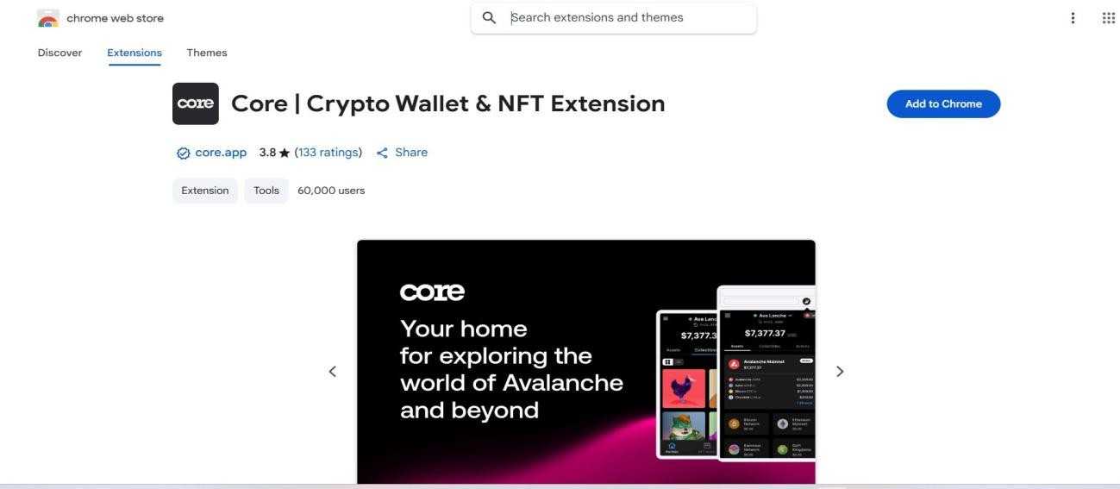

**Step 1:** Verified that the Chrome browser successfully added the wallet extension without any installation errors.

**Step 2:** Launched the extension to check if it opens and loads properly.

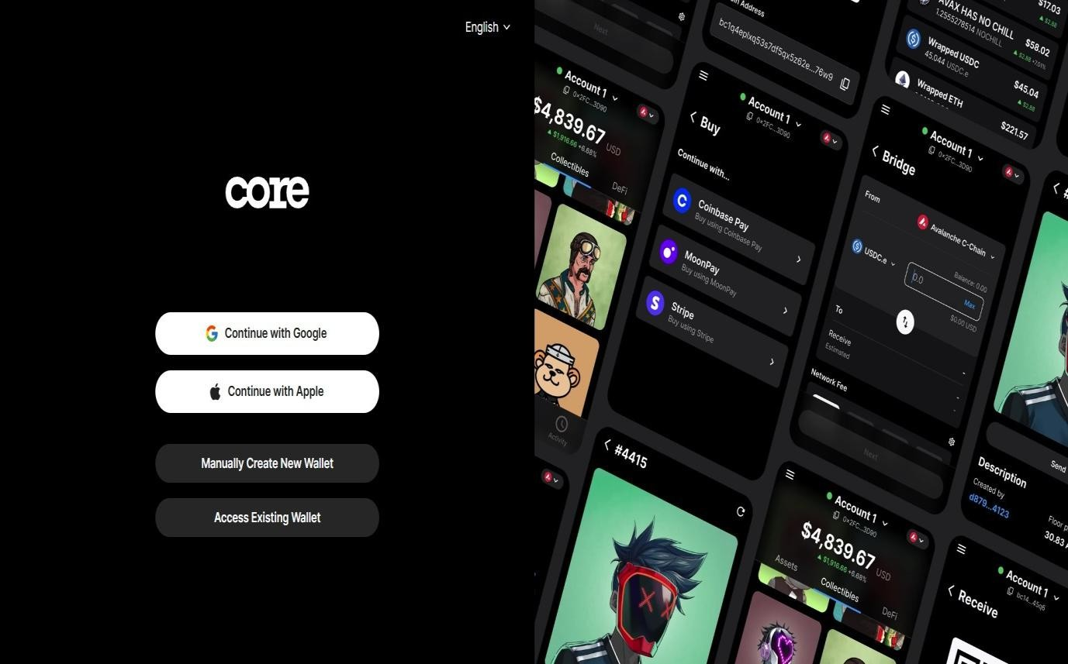

**Step 3:** Clicked on "Create Wallet" and checked that the seed phrase was displayed once without any glitches.

**Step 4:** Entered the seed phrase correctly to verify and proceed.

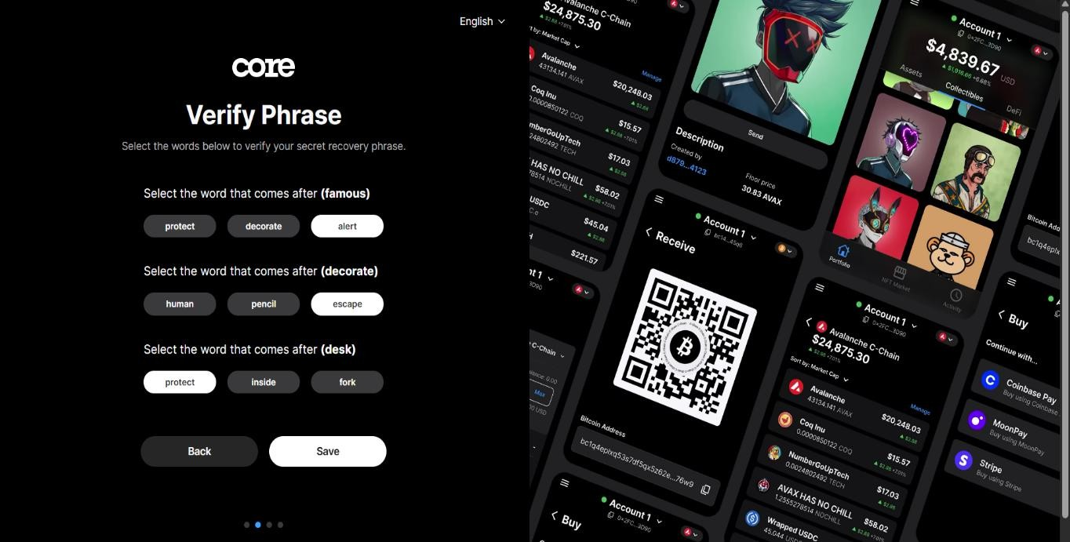

**Step 5:** A seed phrase will be displayed.

* + - Write down the seed phrase and store it securely.
    - *Note:* This phrase is shown only once. If lost, the wallet cannot be recovered.

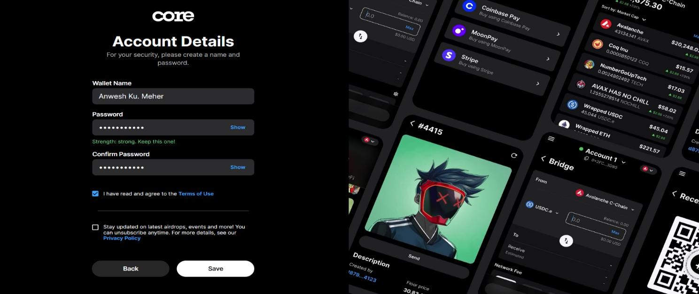

**Step 8:** Create a wallet name and set a strong password for your account.

**Step 9:** Confirmed that the wallet was created and the portfolio/dashboard page was visible without issues.

**Step 10:** Once created, the wallet dashboard or portfolio page will be displayed, showing your public wallet address and account balance (if any).

## * Implementation Phase: Final Output (no error)

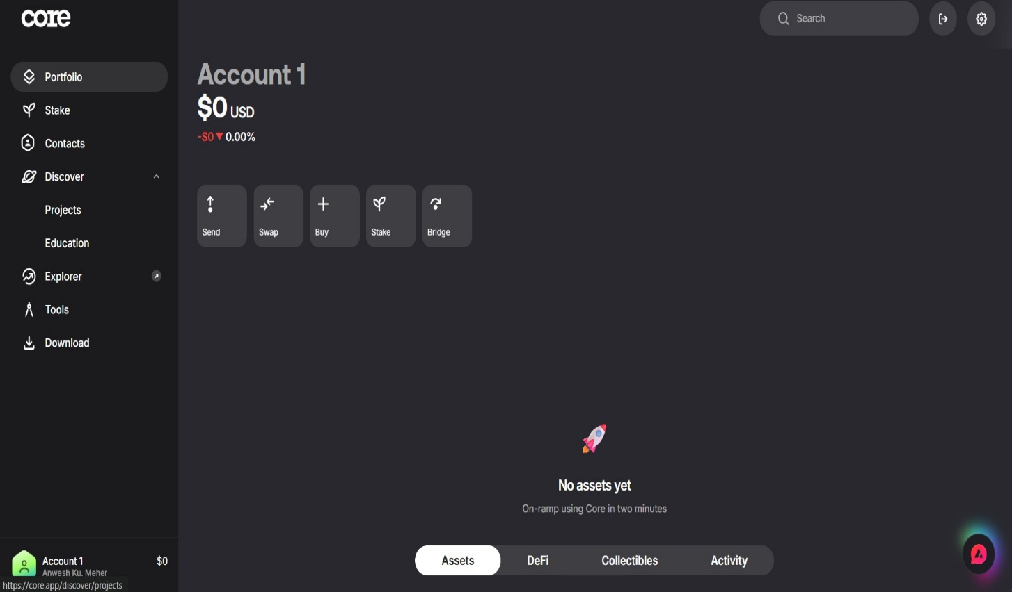Applied and Action Learning

# * Observations

Note:

1. If Seed Phrase is lost then we cannot recover it again.
2. It shows only one Time.
3. We cannot access the private key but we access the public access.

|  |  |  |  |
| --- | --- | --- | --- |
| **Rubrics** |  |  |  |
| Concept | 10 |  |  |
| Planning and Execution/  Practical Simulation/ Programming | 10 |  |  |
| Result and Interpretation | 10 |  |  |
| Record of Applied and Action Learning | 10 |  |  |
| Viva | 10 |  |  |
| **Total** | **50** |  |  |

***Signature of the Student:***

***Signature of the Faculty:***

